# How to Configure Smeal Exchange on an iPhone/iPad/iPod

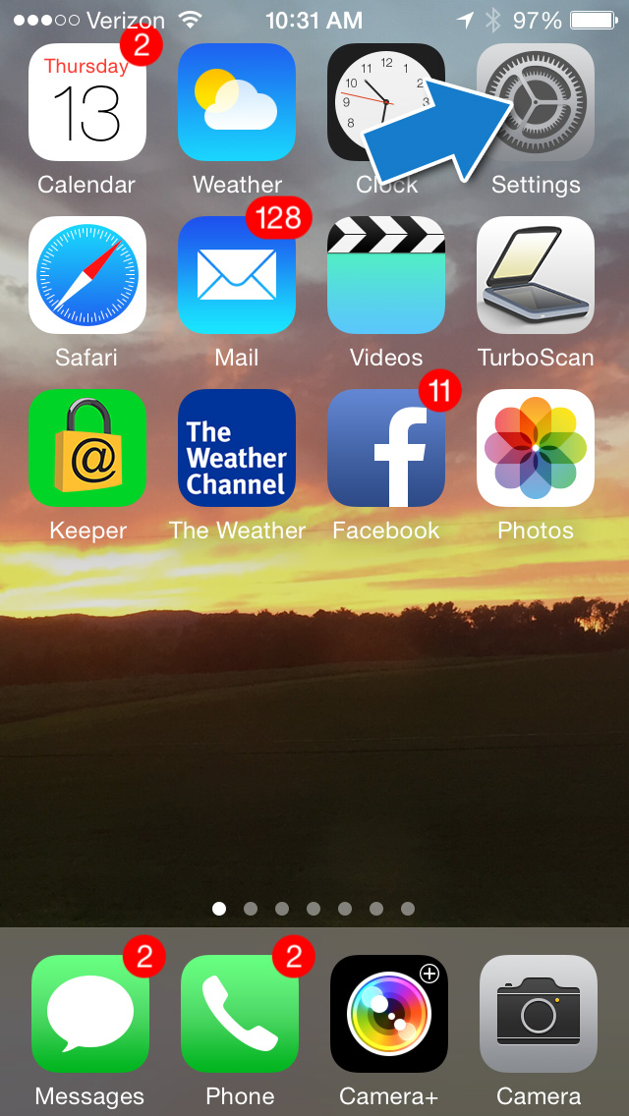

* **Tap Settings**

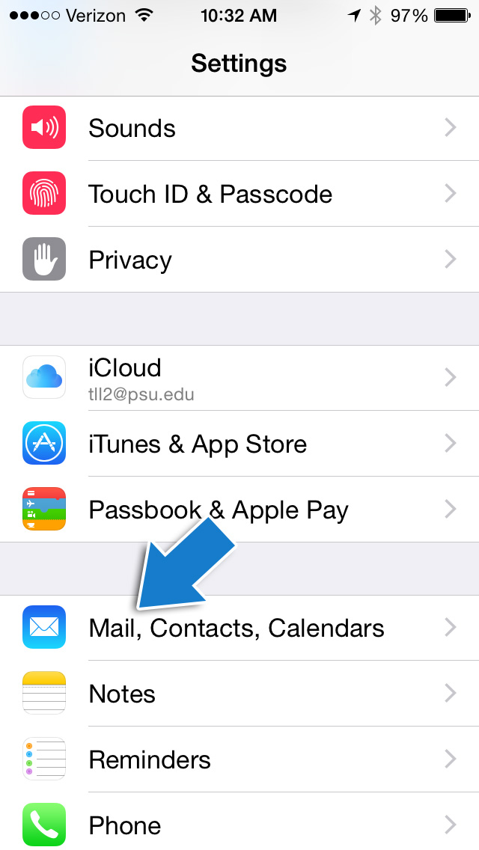

* **Tap Mail, Contacts, Calendars**

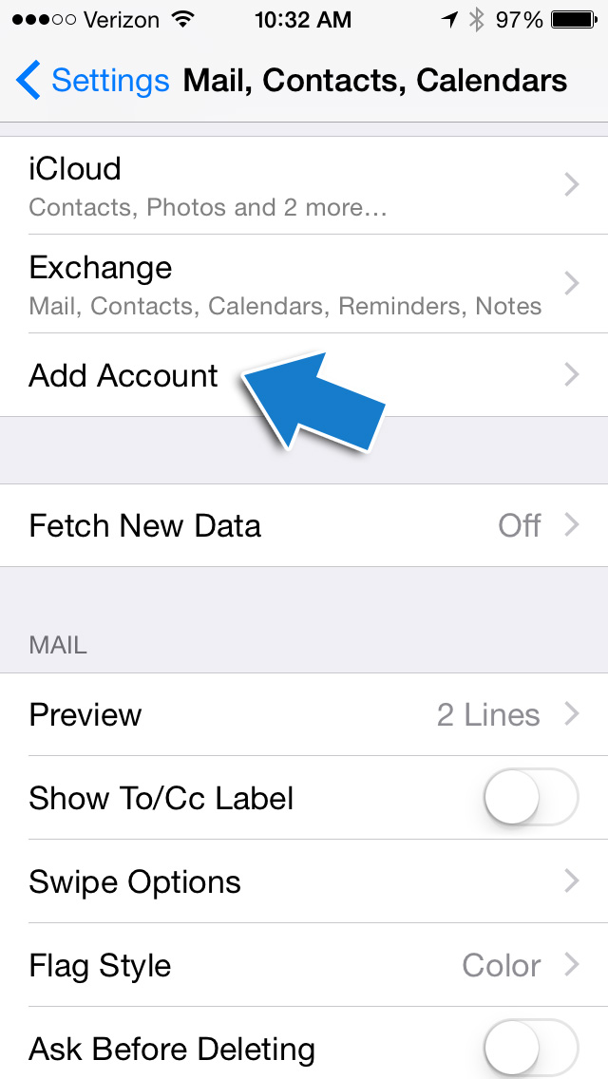

* **Tap Add Account**

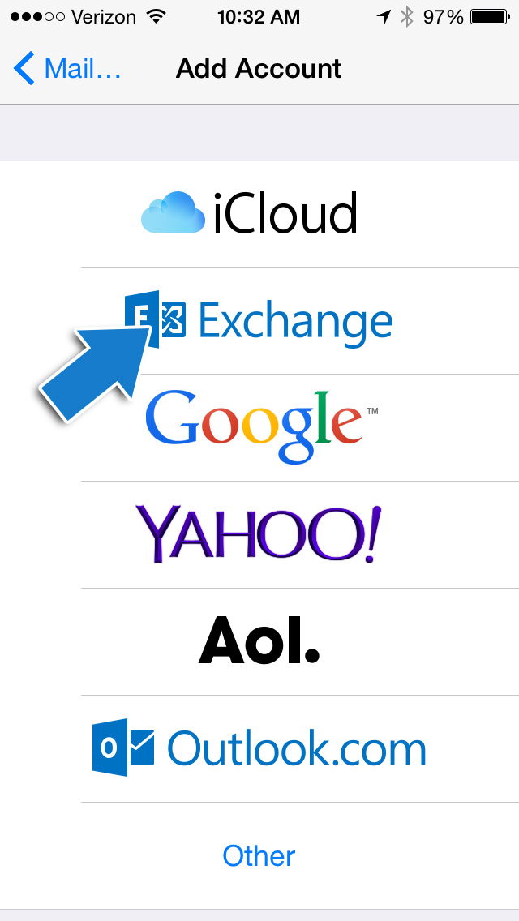

* **Tap Exchange**

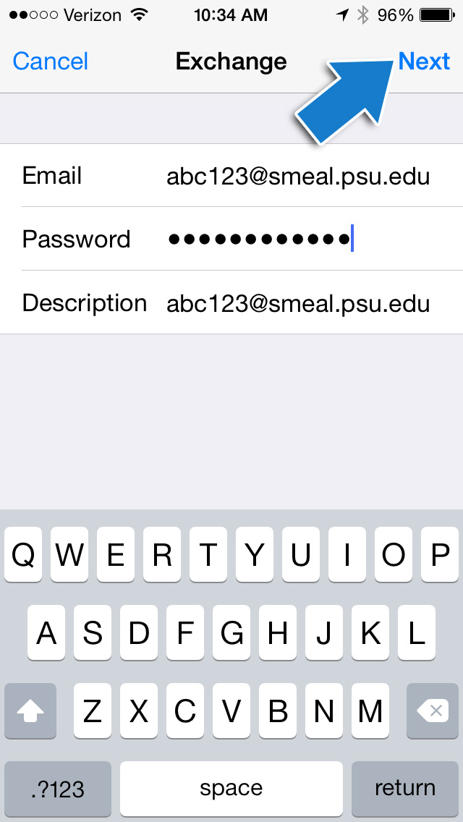

* **Email**: [**abc123@psu.edu**](mailto:abc123@psu.edu) or if you are an MBA or Ph.D. student, you may need to enter [**abc123@smeal.psu.edu**](mailto:abc123@smeal.psu.edu) (**abc123=your username**).
* Server: **exchange.smeal.psu.edu**
* Domain: **smeal.psu.edu**

* Username: **Your PSU username**
* Password: **Your Smeal Exchange Email password**
* **Tap Next at the top right corner of the screen.**

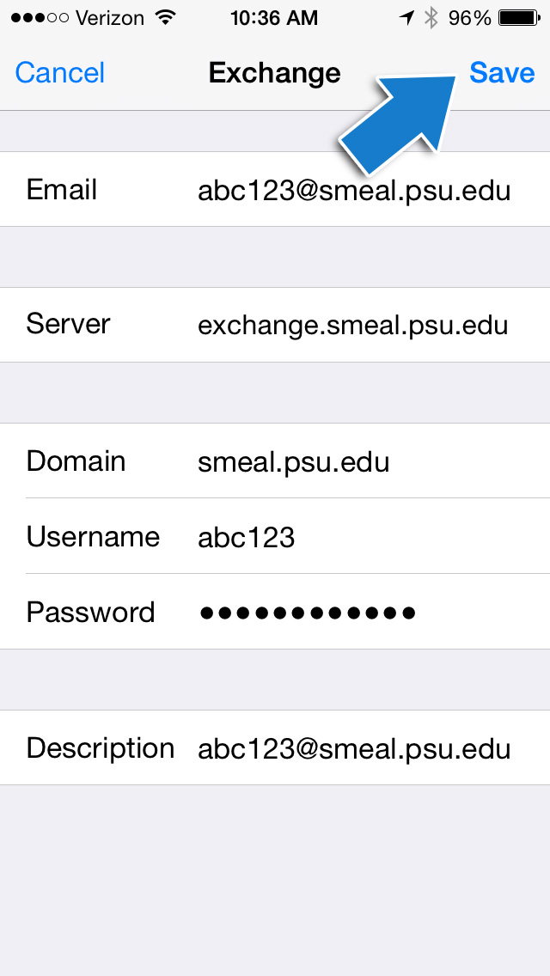

* **Tap Save.**

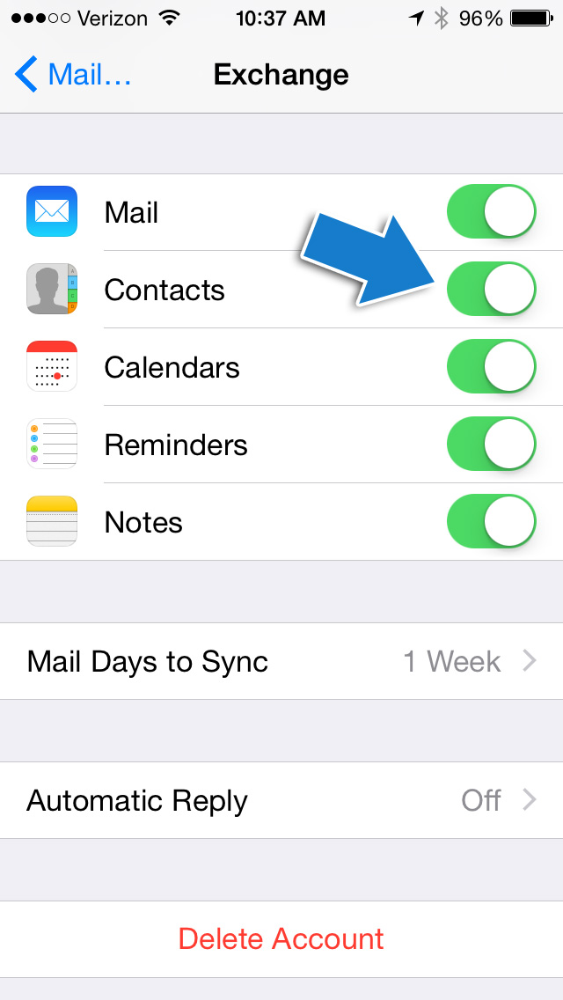

* **NOTE**: If you don’t want your Outlook contacts to sync with your iPhone, iPad, or iPod contacts, tap to turn it off in Settings>Mail, contacts, Calendar > Exchange settings.
* You can also delete the account by tapping Delete Account. This will only delete the configured account from your iPhone, iPad, or iPod.