A/V System User Guide

This conference room is equipped a data projector, with a stationary furniture layout (fixed table).

Table of Contents
Technical Assistance Information……………………………….2
Presentation Setup……………………………………………….3
Internet Connection……………………………………………...4
Phone Connection……………………………………………….4
Projection Troubleshooting Tips…..…………………………….5

PLEASE DO NOT REMOVE FURNITURE OR EQUIPMENT FROM THIS ROOM WITHOUT FIRST CONTACTING THE RIIT GROUP

IF YOUR EVENT INVOLVES FOOD OR BEVERAGE, PLEASE MAKE SURE THE CONFERENCE ROOM IS LEFT IN GOOD CONDITION FOR THE NEXT EVENT
(CLEANING SUPPLIES PROVIDED INSIDE CREDENZA CABINET)

Technical Assistance Information
Conference rooms equipped with data projectors should have instructions placed inside the Credenza cabinet (see labeled door, Figure 1-1). For additional support, you may want to schedule technical assistance through Footprints (by contacting your departmental staff assistant to issue a work order) or by emailing riit@smeal.psu.edu. If you are experiencing problems with your presentation (missing/broken cables, etc.), please call for assistance at (814) 865-0366.
The phone is located inside the labeled Credenza cabinet

Conference rooms equipped with data projectors should have projector remote control and instructions placed inside the Credenza cabinet (door labeled). If you need additional support, you may want to schedule technical assistance through Footprints (contacting your departmental staff assistant to issue a work order) or by emailing riit@smeal.psu.edu.
Step 1 - Based on your presentation requirements, connect the provided VGA, audio, and network cables from the connection/power flip box on the table to your laptop. | 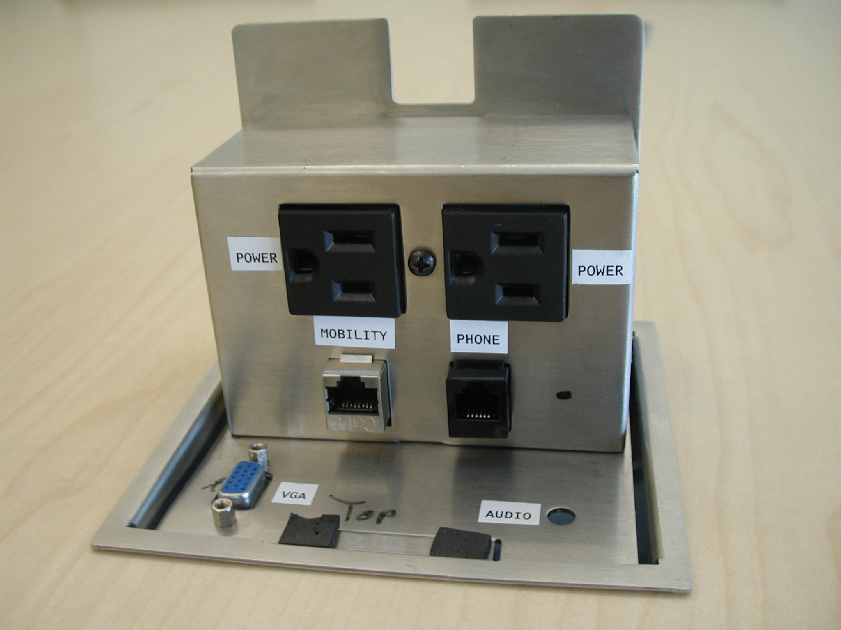
Step 2 – Lower the projection screen using the buttons located on the wall near the screen. | 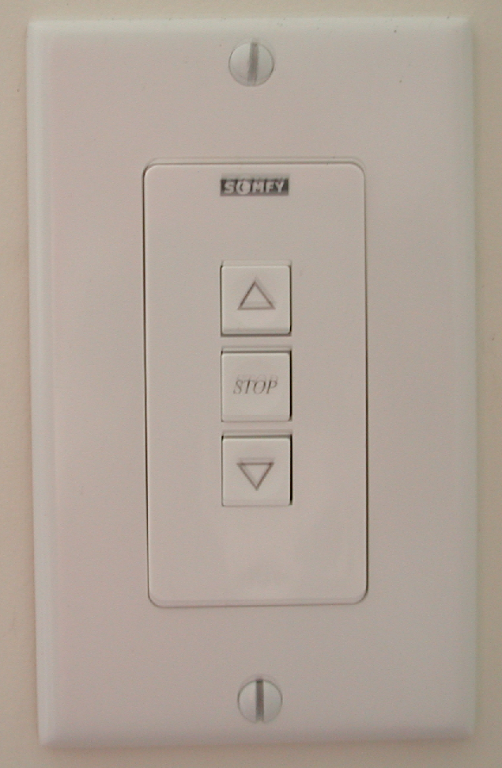
Step 3 - Turn on the ceiling data projector using the provided remote control. If the correct source for the projector is not already chosen, press the BNC button for laptop presentation or the Video button for external media device. | 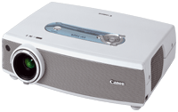
Step 4 – In the case of laptop presentation, you need to send the signal from your laptop to the projector by holding the function (Fn) key and pressing the proper F# key, depending on your laptop model. The following list may help: | 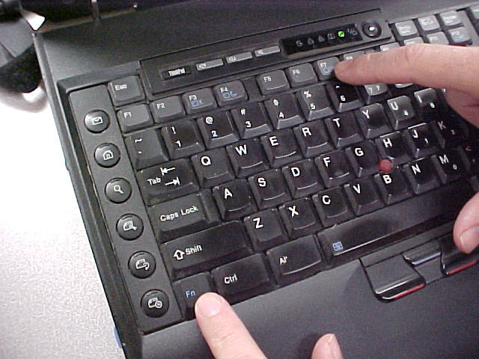
  Manufacturer | Key
  Acer | Fn + F5
  Dell | Fn + F8
  HP | Fn + F5
  IBM ThinkPad | Fn + F7
  Sony | Fn + F7
  Toshiba | Fn + F5
INTERNET CONNECTION

If an internet connection is required, there are two options:
- Wired – LAN connection
- Wireless connection

Whichever connection is used, make sure the other is disabled.

  - Wired – LAN Connection
- Make sure Ethernet cable from the computer is connected into the port labeled “Mobility”
- Open Internet Explorer, select the PSU “Port Login” Site (https://clc.its.psu.edu/PortLogin.aspx)
- Log in using your PSU username/password
- Make sure to logout using PSU “Port Logout” Site (https://clc.its.psu.edu/PortLogout.aspx)

- Wireless Connection
- Open your Wireless Network Connection, connect to “pennstate”
- Open the VPN Client from the desktop
- Double-click “ITS Wireless at UP”
- Log in using your PSU username/password

PHONE CONNECTION

- Polycom conference-call machine available through Footprints or contact the RIIT Group via email: riit@smeal.psu.edu
- The RIIT Group A/V team will setup your phone connection for you based on your request
- This room’s phone number is: (814) 863-1611

Long-Distance Calls
- Lift handset and listen for dial tone
- Enter the access code: 175 and wait for the special tone
- Enter your authorization code and immediately follow with the # sign
- Wait for dial tone
- Enter 8 (to dial outside of University Park)
- Enter all digits you would normally use when placing a call
- NOTE: Any calls placed using an authorization code will be billed against the budget associated with that code

http://tns.its.psu.edu/services/VOICE/authcode.html#sw

PROJECTION TROUBLESHOOTING TIPS
PC (laptop) image does not appear on the projector screen:
- After pressing the correct projection function, make sure you select the option that will show the presentation on projector AND laptop at the resolution 1024 x 768.
- If image still doesn’t project, cycle through available projector inputs to find correct source.
- In case that the image still doesn’t project, check the VGA cable connection and connector for broken pins. If VGA cable is broken, or still cannot get image to project, please call the RIIT Group for immediate assistance at 865-0366.

